Update IOS(ManagementServer)
College of Science, Engineering, and Technology, Grand Canyon University
ITT-216: Enterprise Route & Switch
Instructor Tim Collins
Liela Pressley
5/13//2023
Update IOS(ManagementServer)
- Connected a 2960 switch to server and 2911 router via copper straight-through cable 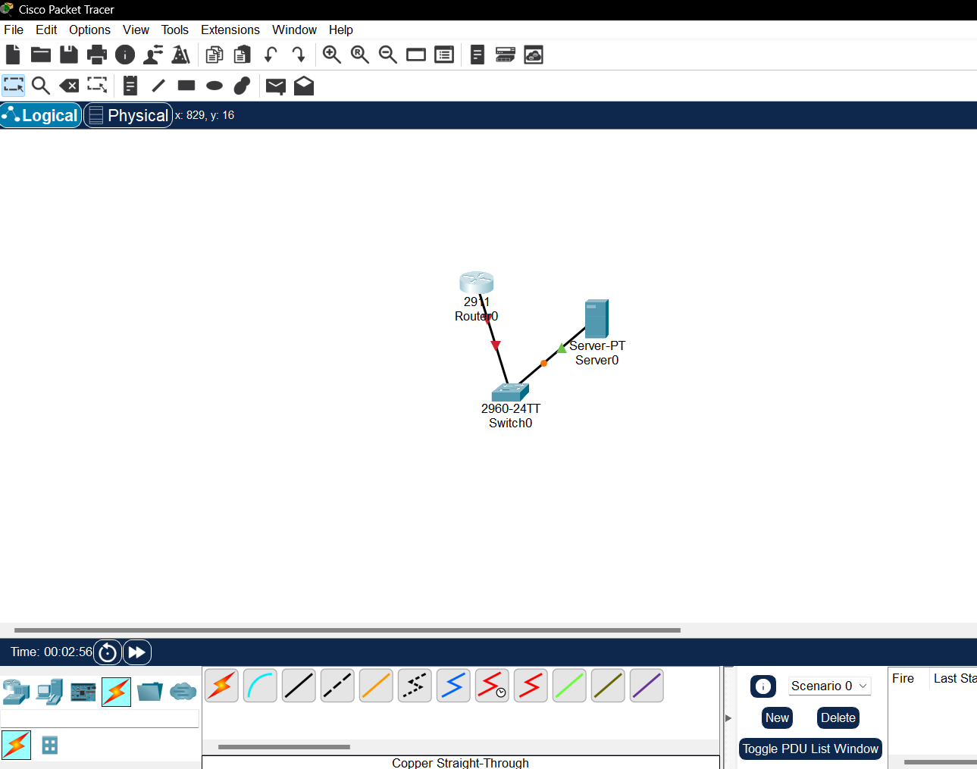
- Configuring ip address 10.10.42.60 for the router port g0/0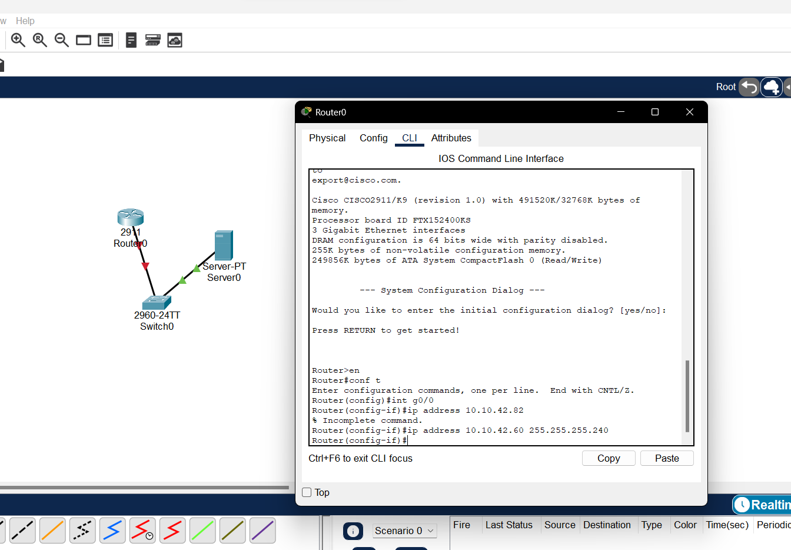
- Configure the dns server and static ip and default gateway 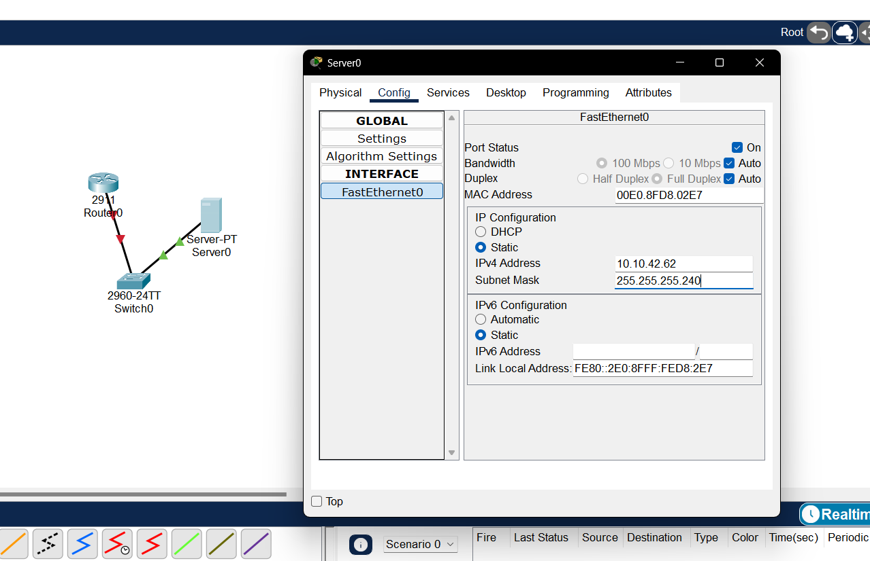
- Successfully pinging default gateway 10.10.42.60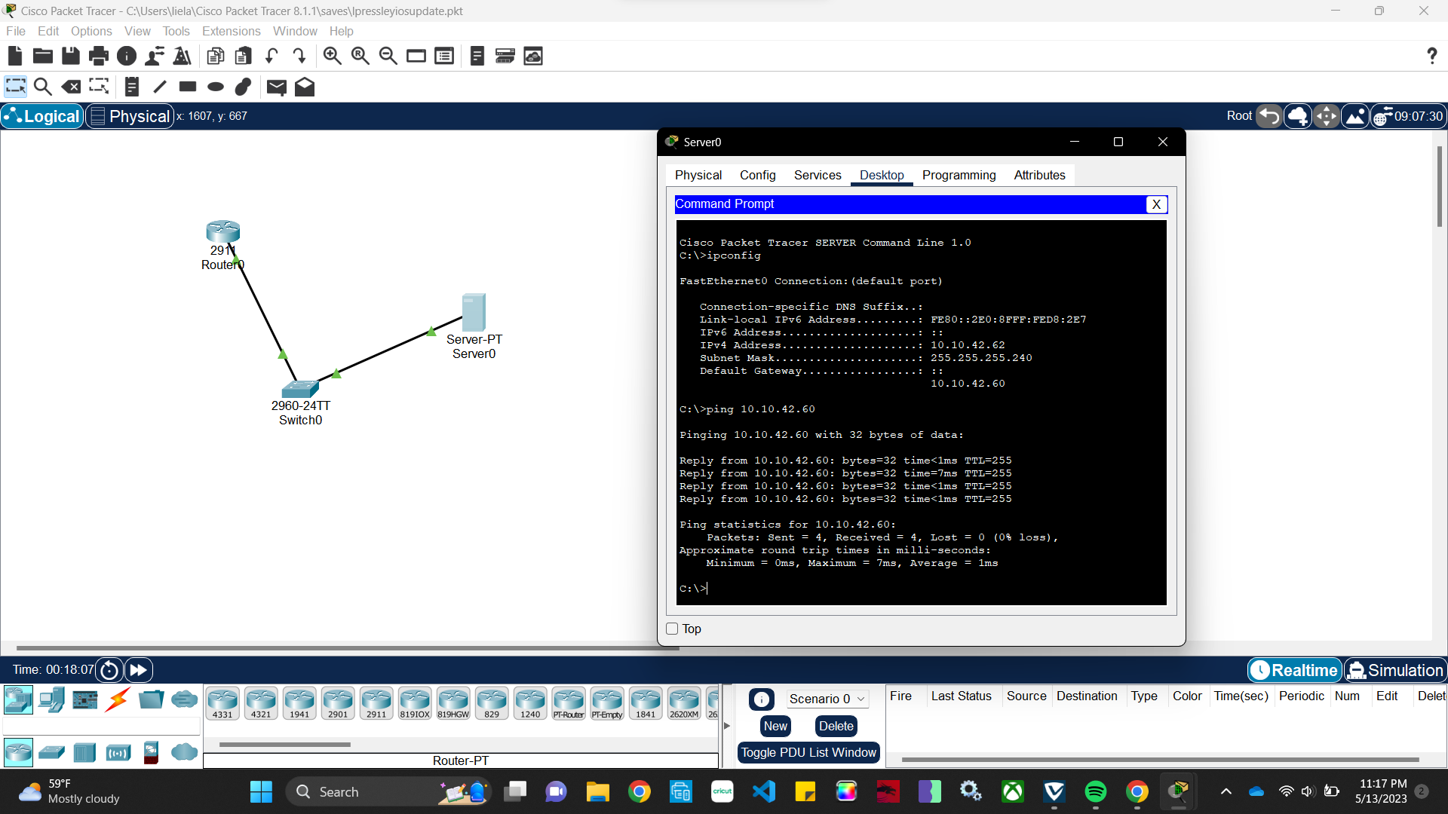
- Add an IEP address to server by creating default gateway vlan 1 address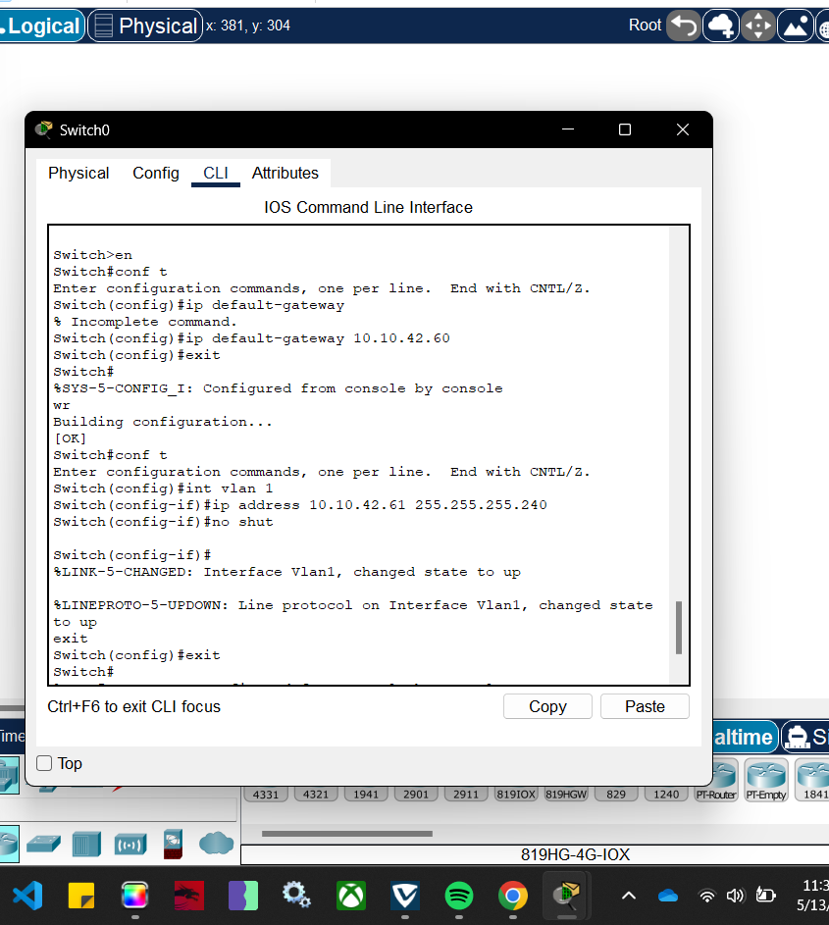
- Successfully added the vlan and default gateway and successfully ping the server from the switch- fully established connection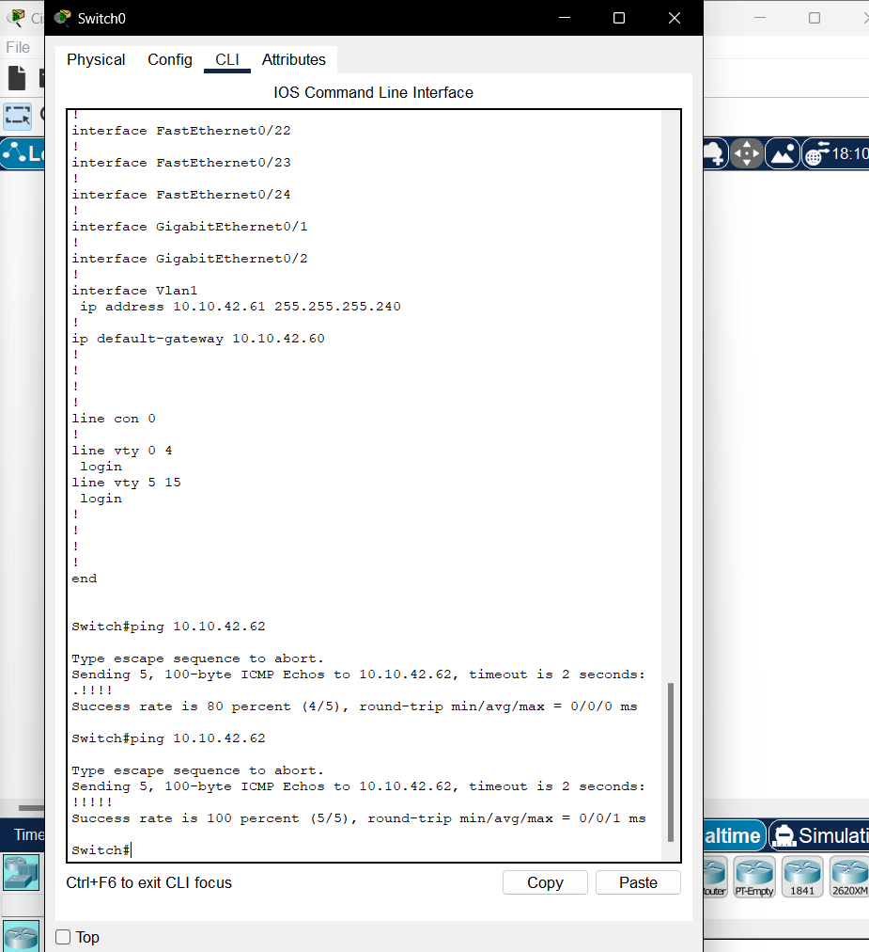
- Show what is currently in storage tftp file for 10.10.42.62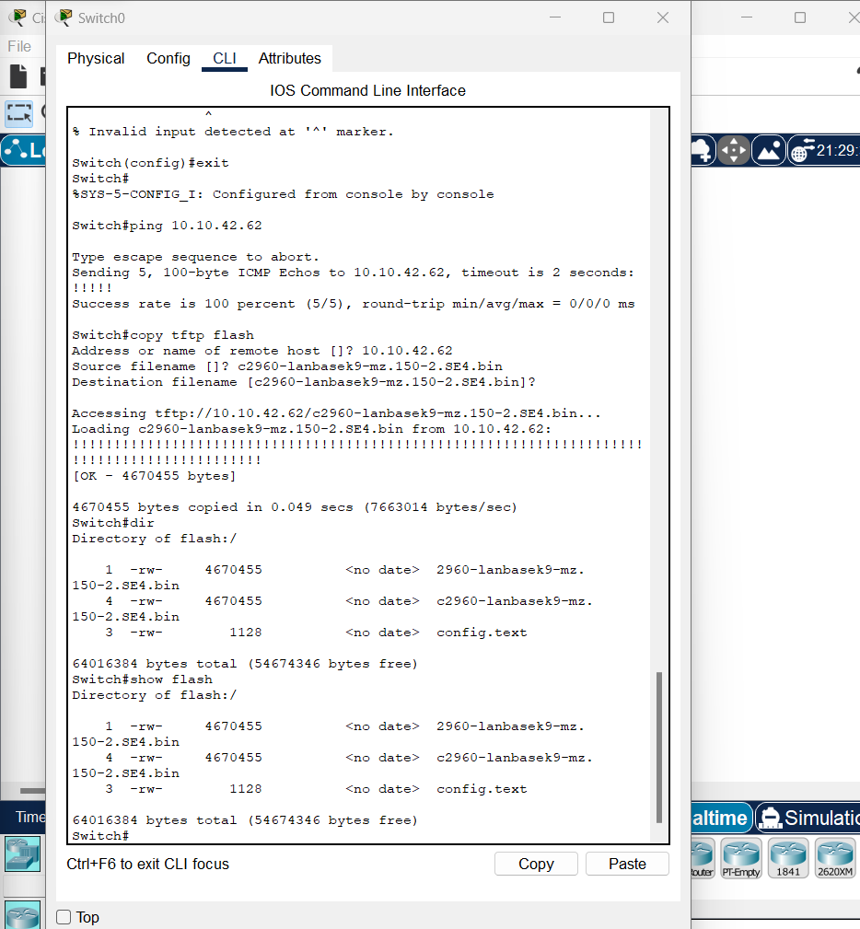
- Boot system and reload the switch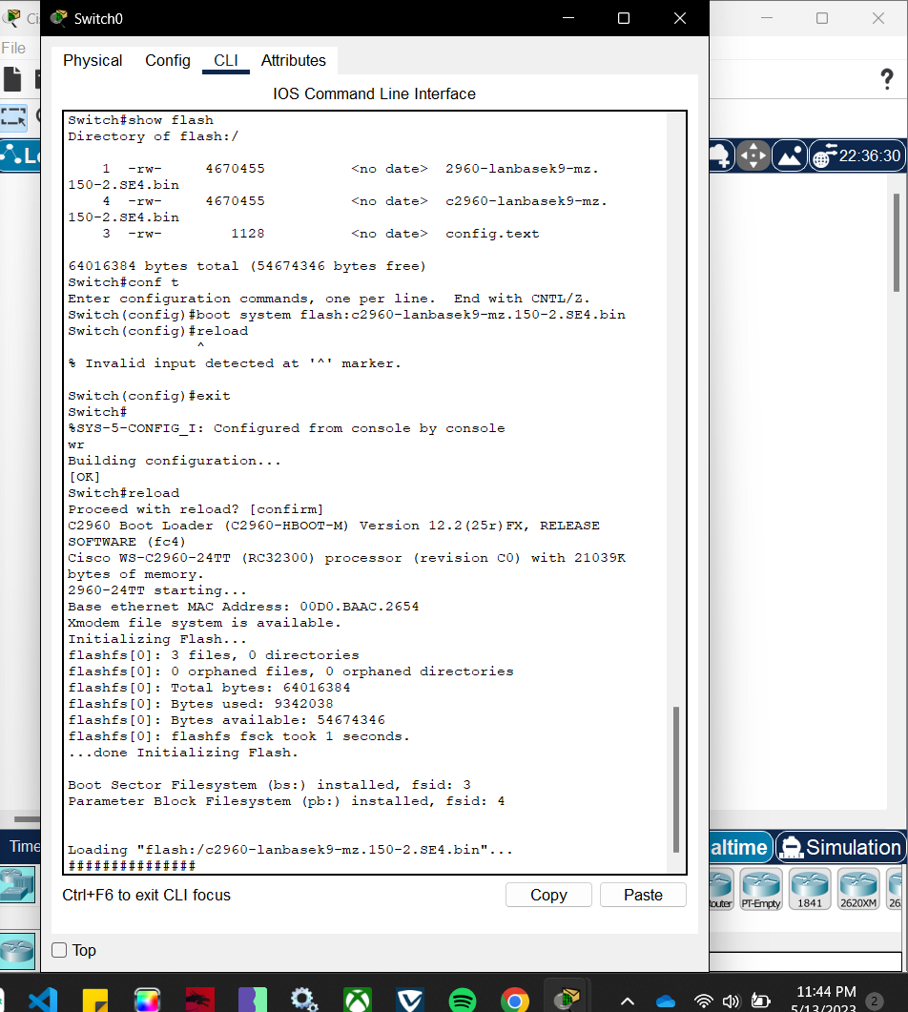
- You can see that we successfully updated the file